**NOMINATION FORM**

**CATTLE AUSTRALIA REGIONAL CONSULTATIVE COMMITTEE**

**About the Regional Consultative Committee**

Cattle Australia has a Regional Consultative Committee (RCC), consisting of one chairperson (appointed by the Board), one Individual Member or Associate Member per sub-region (of which there are 15 covering the whole of Australia), and a number of representatives equal to the number of State Farming Organisations (SFO) that are Members (currently 7), with each representative being appointed by the respective SFO.

**Role of the RCC**

The role of the RCC is to advise on issues affecting the grass-fed cattle industry via engagement and consultation with grass-levy cattle levy payers at a grass roots level. RCC representatives will

• play a key role in shaping the future of the grass-fed cattle industry, ensuring the voices of Australian cattle producers are heard during critical decision-making processes

• be part of a powerful voice representing Australian cattle producers and beef lovers

• be a part of the only legislated organisation dedicated to representing grass-fed cattle producers

• build on the work of previous leaders within Cattle Australia, expanding beyond policy to develop strategy around advocacy, consultation of members at a grass-roots level, and engagement of broader society.

**Appointment term**

The RCC Representatives will have a two-year term.

View the Cattle Australia Constitution [here a](https://cattleaustralia.com.au/wp-content/uploads/2023/10/Cattle-Australia-Constitution-FINAL-Sept-2023.pdf)nd the By-laws [here t](https://cattleaustralia.com.au/wp-content/uploads/2023/09/By-laws-Cattle-Australia-Limited-Aug-2023.pdf)o learn more about the RCC.

**Nominations**

In this election, Cattle Australia is seeking nominations for 8 RCC representatives – one from each of the 8 sub-regions depicted in *Figure 1* – to be elected by Cattle Australia members from each sub-region. The other 7 sub-regions will be up for election next year. Election to the Cattle Australia RCC represents a great opportunity to apply your knowledge and skills to support the grass-fed cattle industry’s growth and prosperity.

The schedule for the election process is as follows:

|  |  |
| --- | --- |
| **Date** | **Activity** |
| **Monday 2 September** | Nominations open |
| **Monday 30 September (11pm AEST)** | Nominations close |
| **Tuesday 15 October (5pm AEDT)** | Voting period opens |
| **Tuesday 5 November (9am AEDT)** | Voting period closes |
| **Thursday 21 November** | Cattle Australia Annual General Meeting |

**Nominee eligibility**

To be eligible for election as a representative of the RCC, you must:

* be an Individual Member* or Associate Member of Cattle Australia
* be allocated to the sub-region in respect of which you are seeking election.

* Financial Member of Cattle Australia

**Nominee selection criteria**

Nominees for RCC must have the following competencies or experience:

• Experience in the grass-fed cattle industry.

• An active community member in their sub-region.

• Respected reputation.

• A drive to help lead the way.

**Nomination process**

Any two Individual Members, each of whom are allocated to the same Sub-Region as the proposed Sub-Regional representative, may nominate an Individual Member or Associate Member who is also allocated to that Sub-Region for election. The 8 Sub-Regions are outlined below.

For a full list of postcodes that are contained in each subregion, visit [www.cattleaustralia.com.au/rcc](http://www.cattleaustralia.com.au/rcc)

*Figure 1.*

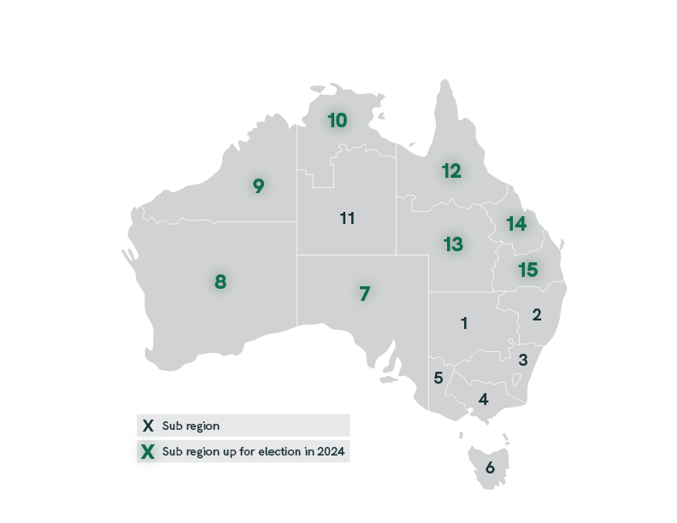

***For example:*** *Rosie Peters and Joy Lucas are Individual Members of Cattle Australia, both residing in Sub- Region 1. Rosie and Joy both agree that Lily Thompson, a fellow producer in Sub-Region 1, would be a great representative for Sub-Region 1 on the Regional Consultative Committee. Rosie and Joy approach Lily to see if she would agree to be nominated.*

*Lily consents as she meets the eligibility, so the three of them fill out and sign the nomination form. The completed form is then submitted to Cattle Australia by the set nomination deadline. Lily is now a candidate in the Cattle Australia RCC election for Sub-Region 1.*

**Nominee applications**

Nominee applications should include the following:

• A completed ‘Regional Consultative Committee - Nomination Form’ (see p4-6) with nominee details and the details of two nominators as outlined above.

• A profile photo of the nominee.

All nominees will be required to submit the nomination form by **11pm AEST on Monday 30 September 2024** to [info@cattleaustralia.com.au.](mailto:info@cattleaustralia.com.au)

Where multiple nominations are received for an Elected RCC position, nominations will be put to members in that specific Sub-Region for voting.

Please note that the information you provide in your nomination form will be used during the nomination and voting process.

For more information, please contact Cattle Australia at [info@cattleaustralia.com.au o](mailto:info@cattleaustralia.com.au)r call

1300 653 038.

**Regional Consultative Committee – Nomination Form**

**Nominee details**

|  |  |
| --- | --- |
| Title |  |
| Full name |  |
| Occupation |  |
| Occupation |  |
| Address (Should be in the Sub-Region you are nominating for) |  |
| City/town |  |
| State |  |
| Postcode |  |
| Email address |  |
| Phone |  |

**Nominee questions**

Please keep each response to the questions below to a maximum of 300 words. Content beyond 300 words will not be used.

|  |  |
| --- | --- |
| Which sub-region are you  nominating for? |  |
| Please provide a brief biography  (tell us about yourself) |  |
| Why are you seeking a position  on the RCC? |  |
| How will you represent the  interests of the grass-fed cattle industry as a representative on the RCC? |  |
| **Describe how you meet at least**  **ONE of the selection criteria:** | **Nominee response** |
| 1. Experience in the grass-fed  cattle industry. |  |
| 2. An active community  member in your sub-region. |  |
| 3. Respected reputation. |  |
| 4. A drive to lead the way. |  |

**Declaration**

I, [insert name], a member of Cattle Australia, accept this nomination to the Cattle Australia

Regional Consultative Committee.

Signature:

Date: Click or tap to enter a date.

**Nominator details**

|  |  |
| --- | --- |
| **Nominator 1** | |
| Full name |  |
| Address (incl. state and  postcode) |  |
| Sub-Region |  |
| Email address |  |
| Signature |  |
| Date | Click or tap to enter a date. |

|  |  |
| --- | --- |
| **Nominator 2** | |
| Full name |  |
| Address (incl. state and  postcode) |  |
| Sub-Region |  |
| Email address |  |
| Signature |  |
| Date | Click or tap to enter a date. |

6