**NOMINATION FORM**

**CATTLE AUSTRALIA ELECTED BOARD DIRECTOR**

**About the Board**

Cattle Australia has a nine-person Board of Directors, consisting of seven democratically elected Directors. This includes three directors from NABR (the North Australia Beef Research Council region); three directors from SALR (the Southern Australia Livestock Research Council region); and one director from WALR (the Western Australian Livestock Council region). These seven democratically elected Directors are responsible for appointing two skills-based Directors. Directors determine the Chair of the Board.

**Role of the Board**

The Cattle Australia Board sets the strategic direction for the organisation, to help it achieve its purpose of representing the interests of the grass-fed cattle industry, by providing a visible, unified, and influential voice for grass-fed levy payers. It also establishes Cattle Australia’s governance framework and ensures it fulfils its financial and legal obligations.

Election to the Cattle Australia Board of Directors represents a great opportunity to apply your knowledge and skills to lead the grass-fed cattle industry, by ensuring that the industry’s national peak body provides a strong, influential and inclusive voice for producers and supports the prosperity of the grass-fed cattle sector.

**Nominations and appointment term**

In this election, Cattle Australia is seeking nominations for two Board Directors – one position in SALR and one position in NABR - to be elected by Cattle Australia members for a three-year term.

The schedule for the election process is as follows:

|  |  |
| --- | --- |
| **Date** | **Activity** |
| **Monday 2 September** | Nominations open (as per Cattle Australia constitutional requirements) |
| **Monday 30 September (11pm AEST)** | Nominations close |
| **Tuesday 15 October (5pm AEDT)** | Voting period opens |
| **Tuesday 5 November (9am AEDT)** | Voting period closes |
| **Thursday 21 November** | Annual General Meeting with announcement of Cattle Australia Board |

View the Cattle Australia Constitution [here](https://cattleaustralia.com.au/wp-content/uploads/2023/10/Cattle-Australia-Constitution-FINAL-Sept-2023.pdf) and the By-Laws [here](https://cattleaustralia.com.au/wp-content/uploads/2023/09/By-laws-Cattle-Australia-Limited-Aug-2023.pdf) to learn more about the governance and processes of Cattle Australia.

For an overview of the responsibilities of a Board Director, please visit the Australian Securities and Investments Commission [here](https://asic.gov.au/for-business/small-business/starting-a-company/small-business-company-directors/#responsibilities) or the Australian Institute of Company Directors [here](https://www.aicd.com.au/corporate-governance-sectors/not-for-profit/principles/roles-and-responsibilities.html).

**Nominee eligibility**

To be eligible for election as an Elected Director of Cattle Australia, you must:

* be an Individual Member of Cattle Australia or the representative of an Individual Member noted in the Membership Register
* be allocated to the Region in respect of which you are seeking election
* not be an employee of Cattle Australia or any state farming organisation
* have given your consent to act as a Director to Cattle Australia
* not be otherwise prohibited by law from being a director of a company.

**Nominee selection criteria**

Nominees for Elected Directors must have at least **one**of the following competencies or experience:

* Experience in the grass-fed cattle industry.
* Understanding of the purpose of a peak industry body.
* Experience in developing corporate strategy.
* Respected professional reputation.
* Legitimacy and credibility, including relevant networks.
* Business development, acumen and experience in business diversification.
* Prior or current Board experience or formal governance training.
* Experience in areas such as finance, accounting, audit or risk management.
* Management experience, particularly as CEO of an organisation in the grass-fed cattle sector.

**Nomination process**

Any five Individual Members who ordinarily reside in one of the three Regions (NABR, SALR or WALR) may nominate an Individual Member for election as an Elected Director.

The relevant Regions are outlined in Figure 1.

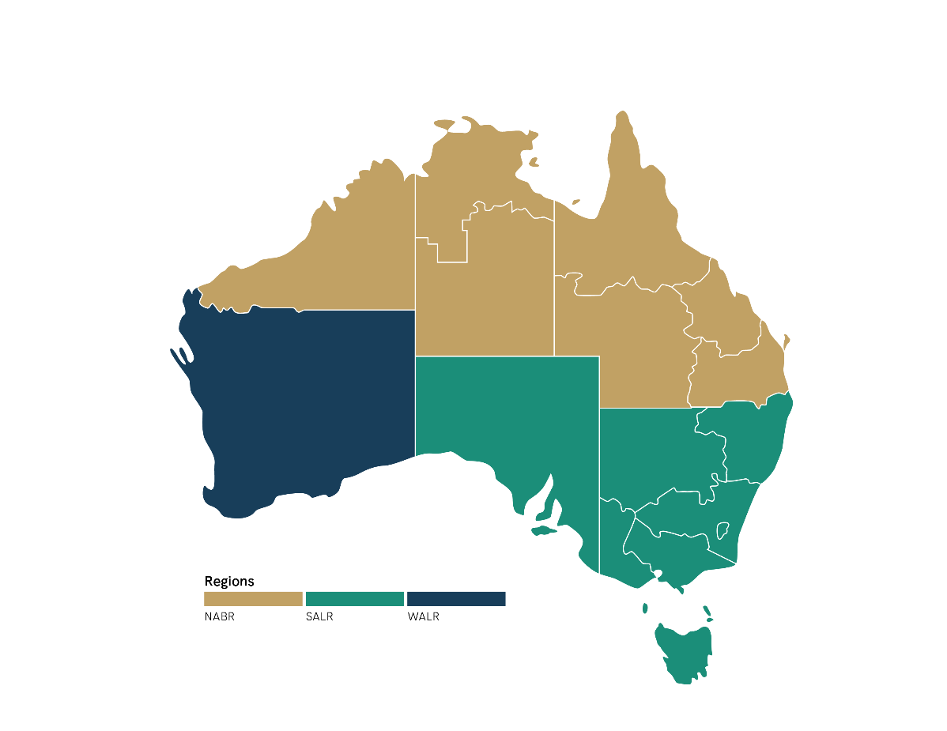

Figure 1.

***For example:*** *Fred Woods is an Individual Member of Cattle Australia residing in the SALR Region.*

*Fred and four other Individual Cattle Australia Members from the SALR Region all agree that Brett James, a fellow producer in the SALR Region, would be a great Cattle Australia Board Director. The group approach Brett to see if he would agree to be nominated.*

*Brett consents as he meets the eligibility, so the six of them fill out and sign the nomination form. The completed form is then submitted to Cattle Australia by the set nomination deadline. Brett is now a candidate in the Cattle Australia Board election.*

**Nominee applications**

Nominee applications should include the following:

* A completed ‘Elected Director - Nomination Form’ (see p4-6) with nominee details and the details of five nominators as outlined above.
* A profile photo of the nominee.

All nominees will be required to submit the nomination form by **11pm AEST on Monday 30 September 2024** to [info@cattleaustralia.com.au](mailto:info@cattleaustralia.com.au).

Where multiple nominations are received for an Elected Director position, nominations will be put to members for voting.

Please note that the information you provide in your nomination form will be used during the nomination and voting process.

Please note that if elected as a Cattle Australia Director, you will be required to apply for a director identification number through the Australian Business Registry Services (if you do not currently have one). This is a government requirement. More information can be found [here](https://www.abrs.gov.au/director-identification-number).

For more information, please contact Cattle Australia at [info@cattleaustralia.com.au](mailto:info@cattleaustralia.com.au) or call   
1300 653 038.

**Elected Director – Nomination Form**

|  |  |
| --- | --- |
| Title |  |
| Full name |  |
| Organisation |  |
| Occupation |  |
| Address |  |
| City/town |  |
| State |  |
| Postcode |  |
| Email address |  |
| Phone |  |

**Nominee details**

**Nominee questions**

Please keep each response to the questions below to a maximum of 300 words. Content beyond 300 words will not be used.

|  |  |
| --- | --- |
| Brief biography (tell us about yourself) |  |
| Why are you seeking a position on the Board? |  |
| How will you represent the interests of the grass-fed cattle industry as a Director? |  |
| **Describe how you meet at least ONE of the selection criteria below for this Board position:** | **Nominee response** |
| 1. Experience in the grass-fed cattle industry. |  |
| 1. Understanding of the purpose of a peak industry body. |  |
| 1. Experience in developing corporate strategy. |  |
| 1. Respected professional reputation. |  |
| 1. Legitimacy and credibility, including relevant networks. |  |
| 1. Business acumen and experience in business diversification. |  |
| 1. Prior or current Board experience or formal governance training. |  |
| 1. Experience in areas such as finance, accounting, audit or risk management. |  |
| 1. Management experience, particularly as CEO of an organisation in the grass-fed cattle sector. |  |

**Declaration**

I, [insert name], a member of Cattle Australia, accept this nomination to the Cattle Australia Board.

Signature: _____________________________________________________

Date: Click or tap to enter a date.

**Nominator details**

|  |  |
| --- | --- |
| **Nominator 1** | |
| Full name |  |
| Address |  |
| Email address |  |
| Signature |  |
| Date | Click or tap to enter a date. |

|  |  |
| --- | --- |
| **Nominator 2** | |
| Full name |  |
| Address |  |
| Email address |  |
| Signature |  |
| Date | Click or tap to enter a date. |

|  |  |
| --- | --- |
| **Nominator 3** | |
| Full name |  |
| Address |  |
| Email address |  |
| Signature |  |
| Date | Click or tap to enter a date. |

|  |  |
| --- | --- |
| **Nominator 4** | |
| Full name |  |
| Address |  |
| Email address |  |
| Signature |  |
| Date | Click or tap to enter a date. |

|  |  |
| --- | --- |
| **Nominator 5** | |
| Full name |  |
| Address |  |
| Email address |  |
| Signature |  |
| Date | Click or tap to enter a date. |